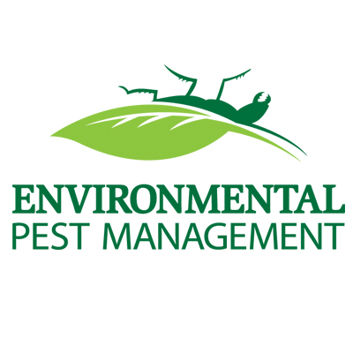

Environmental Pest Management will be treating your home for bed bugs. The ENTIRE home will be treated except for the kitchen. In order to complete a through treatment, please help us with preparing the following items prior to our arrival.

Prior to treatment please do the following:
- Move all items in all rooms of the home (including the 1st & 2nd floor, the entire basement, steps/stairs and hallways) away from all walls at least 18 to 24 inches.
- Remove all bed coverings from mattresses & box springs, and put in the dryer on high heat for 45-60 minutes & then place items into a covered container, or sealed plastic bags.
- Remove all items from dresser drawers and ALL closets. All clothing/linen items must be run through a dry cycle of high heat for 45-60 minutes and placed into a covered container, or sealed plastic bag (no boxes or suitcases). PLEASE DO NOT PUT CLOTHING BACK in drawers or closets until all treatments have been completed and unit is cleared.
- DO NOT place any items on furniture, as this will need to be treated as well.
- Remove all pets from areas to be treated.
(Aquarium aerators should be turned off and aquarium covered with plastic)
6. Run a vacuum over all carpeted areas and furniture prior to treatment.
(Utilizing a crevice tool at baseboards & on furniture is strongly recommended)
(Vacuum bag should be placed in plastic bag and disposed of IMMEDIATELY
- Vacate the home for a minimum of 3 hours after treatment. Federal Law requires that NO person remain inside a unit while a treatment is being performed, unless you are a licensed pest management professional.
- If you are running low on space to store your items, we suggest inside the bathroom shower, or kitchen area.
- If you have applied any sort of pesticides inside your home- it MUST be cleaned prior to our arrival

After your treatment:
- Do not have the carpets cleaned for 60 days; however you may do regular vacuuming.
- For 7 to 10 days following the treatment you may notice an increase in pest activity. If this occurs do not be concerned. This is a result of the treatment driving the pests out of their nesting areas. The pests need to come in contact with the treatment to get a lethal dose and be killed.
- A follow up treatment needs to be completed within 2 weeks after your initial service. Please contact our office to schedule.
- This exact same procedure will be done on the follow up service and you will need to prepare your home the exact same way.
- Do not apply any pesticides/boric acid in your home. This will void our treatment and null the warranty.
- Cover mattresses & box springs with plastic/vinyl/cloth mattress covers after treatment. Failure to do so will void and null the warranty.

