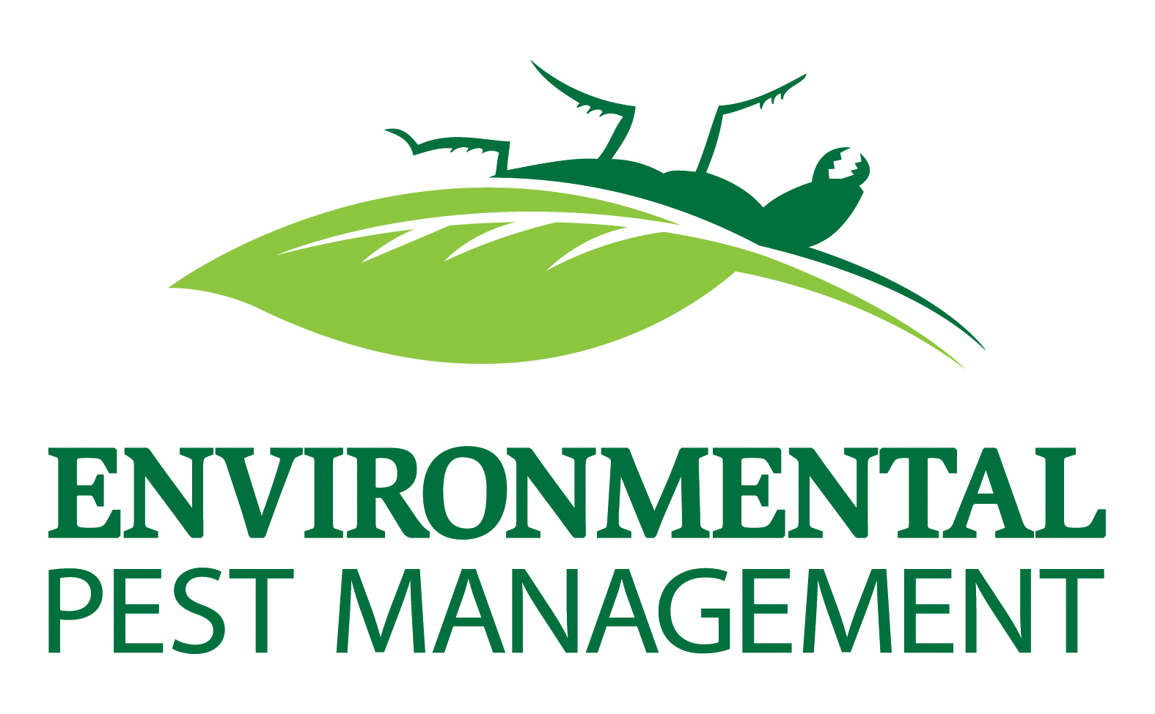

Tarehe: _______________________________
Kwenye ________________________________ Usimamizi wa wadudu wa Mazingira utatibu kitengo chako kwa ukaguzi / matengenezo ya kuzuia. Bila kujali kiwango cha infestation yako, ni muhimu kwa matibabu bora ambayo unaandaa kitengo chako kwa huduma. Utahitaji kufanya sehemu yako kwa:

- turning off any alarm system(s);
- leaving the front door UNCHAINED;
- removing ALL items from under the sink in the kitchen and bathroom.
- removing all pets from areas to be treated;
(Aquarium aerators should be turned off and aquarium covered with plastic)

Ikiwa yoyote ya maagizo haya hayafuatwi, hakuwezi kuwa na dhamana iliyopewa, kitengo chako hakiwezi kutibiwa na / au unaweza kupata malipo ya huduma.

